Module 5 Review
Graph the following functions:
- $y=-5x∙cosx$  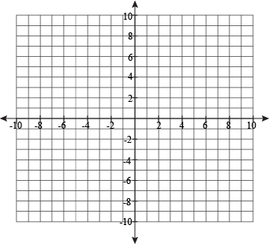 | - $y=3x∙\sin{πx}$
- $y=x^{2}+3sin\frac{π}{2}x$ | - $y=\cos{2πx}+\left|x-4\right|+1$
- $y={\frac{1}{2}}^{x}∙sin2x$ | - $y=-3x+2+sin\frac{π}{2}x$
- Given that $f\left(x\right)=x+1 and g\left(x\right)=cos{πx,}$ graph $f\left(g\left(x\right)\right)$  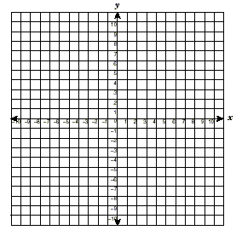 | - Given that $f\left(x\right)=3x-4 and g\left(x\right)=2^{x-1}$  graph $f\left(g\left(x\right)\right)$
For each graph below, write the function graphed and them write the function as a composition of two functions.
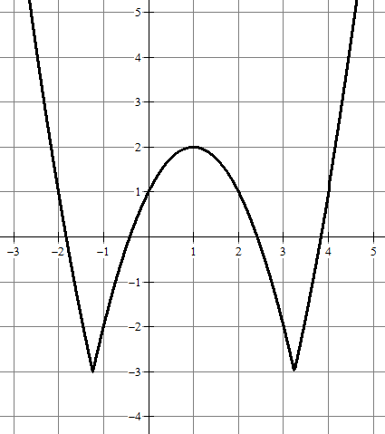 | $Function graphed:___________________________________$  Composed functions;  $k(x)=f(g(x))$  $f(x)=___________________________$  $g(x)=___________________________$
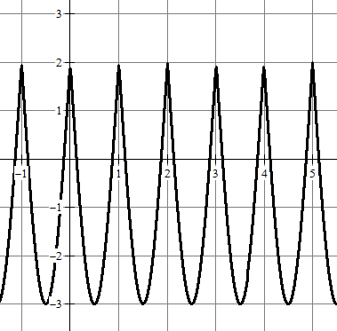 | $Function graphed:___________________________________$  Composed functions;  $k(x)=f(g(x))$  $f(x)=___________________________$  $g(x)=___________________________$

Evaluate each composition using the following functions:
$f\left(x\right)=5x-4$ $g\left(x\right)=-x^{2}+3$ $h\left(x\right)=\sqrt{x-3}$

11. $f\left(g\left(h\left(12\right)\right)\right)$ 12. $\left(h∘g∘f\right)\left(-2\right)$ 13. $g\left(h\left(f\left(\frac{11}{3}\right)\right)\right)$

Given the following equations, answer the questions
$$m\left(x\right)=\frac{x}{1000}$$ | $$c\left(x\right)=\frac{150}{x}$$ | $$w\left(x\right)=60⋅\left(\frac{x-1500}{1500}\right)$$ | $$a\left(x\right)=4x+100$$ | $$p\left(x\right)=30\cos\left(x+1\right)$$
14. Find $m\left(a(x)\right)when t=12$

15. Compose $c\left(p(x\right))$

16. Find $w\left(c(p(2\right))$

- Which composition creates the function, $t\left(x\right)=\frac{120\cos\left(x+1\right)+100}{1000}$

- Your computer's screen saver is an expanding circle. The circle starts as a dot in the middle of the screen and expands outward, changing colors as it grows. With a twenty-one inch screen, you have a viewing area with a 10-inch radius (measured from the center diagonally down to a corner). The circle reaches the corners in four seconds. Express the area of the circle (discounting the area cut off by the edges of the viewing area) as a function of time t in seconds.

- In the mail, you receive a coupon for $5 off of a pair of jeans. When you arrive at the store, you find that all
jeans are 25% off.Let x represent the original cost of the jeans.
  - Write a function, f(x), that represents the effect of your original coupon.
  - Write a function, g(x), that represents the effect of the 25% discount at the store.
  - Write a function, h(x), that represents how much you would pay if you use the mail coupon first followed by applying the discount from the store.
  - Write a function, j(x), that represents how much you would pay if you use the store discount first, followed by the mail coupon.
  - You find a pair of jeans for $36. How much would you pay for it using both functions h(x) and J(x). If you only have $40 with you, what’s the most expensive pair of jeans you can purchase? (do not consider tax).

- Given the following functions, find a composition of functions with each feature listed below.
$a\left(x\right)=\frac{x-1}{x-2}$, $b\left(x\right)=\log_{2}{x}$, $c\left(x\right)=|3x|$, $d\left(x\right)={2x}^{2}+4$, $e\left(x\right)=x-4, f\left(x\right)=x^{2}+5x-4$

  - A composition of functions with a range of $[32, ∞)$
  - A composition of functions with no roots
  - A composition of functions with an asymptote at $x=4$
  - A composition of functions with end behavior: $As x→∞, y→1$
- Given $f\left(x\right)=2x-3, g\left(x\right)= x^{2}-2x, and h\left(x\right)= -5x$. Find $g\left(f\left(h\left(x\right)\right)\right)$.

- Given $f\left(x\right)=2x^{3}-9x^{2}+x+12, g\left(x\right)= 2x-3, and h\left(x\right)= x+1$.
  - Find $g\left(x\right)-f\left(x\right)$

  - Find $g(x)∙h(x)$

  - Find $\frac{f(x)}{g(x)∙h(x)}$

- Given:
$f\left(x\right)=2x-4, g\left(x\right)=\cos{\frac{π}{4}}x, and$ $h\left(x\right)= -5x$
Graph the following:
a. $f\left(g\left(x\right)\right)$b. $(f+g)(x)$
c. $f∙g(x)$

